Name: Abhiram S Sajeev
Roll No: 3
Date: 30/9/2023
EXPERIMENT – 3

MULTI-USER CHAT SERVICE

PROGRAM:

CLIENT

import tkinter as tk
import threading
import socket

def receive_messages():
while True:
try:
message = client_socket.recv(1024).decode('utf-8')
if message:
chat_box.insert(tk.END, message + '\n')
except:
print("An error occurred!")
break

def send_message(event=None):
message = my_message.get()
if message:
chat_box.insert(tk.END, client_name + ':' + message + '\n')
client_socket.send(f"{client_name}:{message}".encode('utf-8'))
my_message.set("") # Clear the input field

root = tk.Tk()
root.title("Chat Application")

frame = tk.Frame(root)
frame.pack(pady=10)

scrollbar = tk.Scrollbar(frame)
scrollbar.pack(side=tk.RIGHT, fill=tk.Y)

chat_box = tk.Text(frame, wrap=tk.WORD, yscrollcommand=scrollbar.set)
chat_box.pack(side=tk.LEFT, fill=tk.BOTH)
scrollbar.config(command=chat_box.yview)

name_label = tk.Label(root, text="Enter your name:")
name_label.pack(pady=(10, 5))

my_name = tk.StringVar()
name_entry = tk.Entry(root, textvariable=my_name)
name_entry.pack(pady=5)

my_message = tk.StringVar()
entry_field = tk.Entry(root, textvariable=my_message, state=tk.DISABLED)
entry_field.bind("<Return>", send_message)
entry_field.pack(pady=5)

send_button = tk.Button(root, text="Send", command=send_message, state=tk.DISABLED)
send_button.pack()

client_socket = socket.socket(socket.AF_INET, socket.SOCK_STREAM)
client_socket.connect(("localhost", 56789))

client_name = ""

def enable_chat():
global client_name
client_name = my_name.get()
entry_field.config(state=tk.NORMAL)
send_button.config(state=tk.NORMAL)
name_submit_button.config(state=tk.DISABLED)

name_submit_button = tk.Button(root, text="Submit Name", command=lambda: enable_chat())
name_submit_button.pack(pady=(0, 10))

receive_thread = threading.Thread(target=receive_messages)
receive_thread.daemon = True
receive_thread.start()

root.mainloop()

client_socket.close()

SERVER

import socket
import threading

clients = []

def broadcast(message, client_socket):
for client in clients:
if client != client_socket:
try:
client.send(message)
except:
remove(client)

def remove(client_socket):
if client_socket in clients:
clients.remove(client_socket)

def handle_client(client_socket):

while True:
try:
message = client_socket.recv(1024).decode('utf-8')
if message:
sender_name, message_content = message.split(":", 1)
reversed_message = message_content[::-1] # Reverse the message content
broadcast(f"{sender_name}: {reversed_message}".encode('utf-8'), client_socket)
else:
remove(client_socket)
break
except:
remove(client_socket)
break

def start_server():
server_socket = socket.socket(socket.AF_INET, socket.SOCK_STREAM)
server_address = ('localhost', 56789)
server_socket.bind(server_address)
server_socket.listen(5)

print(f"Server is listening on {server_address[0]}:{server_address[1]}...")

while True:
client_socket, client_address = server_socket.accept()
clients.append(client_socket)

client_thread = threading.Thread(target=handle_client, args=(client_socket,))
client_thread.start()

if __name__ == '__main__':
start_server()

OUTPUT:

CLIENT
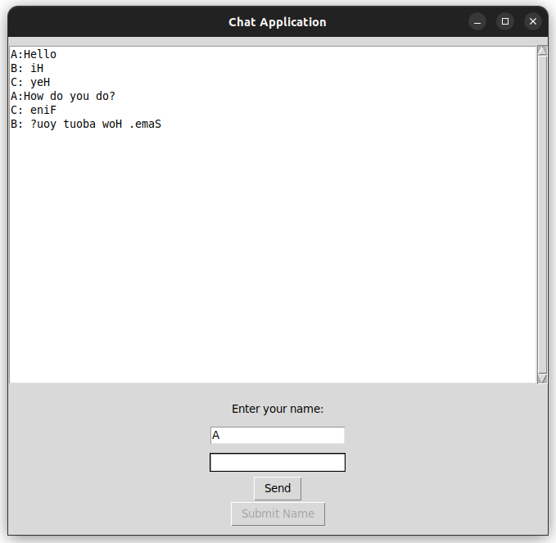
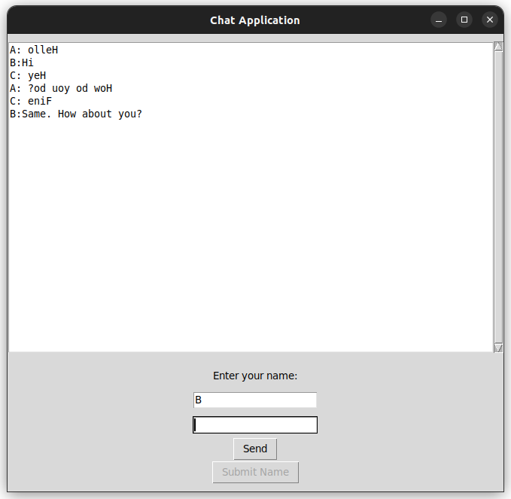
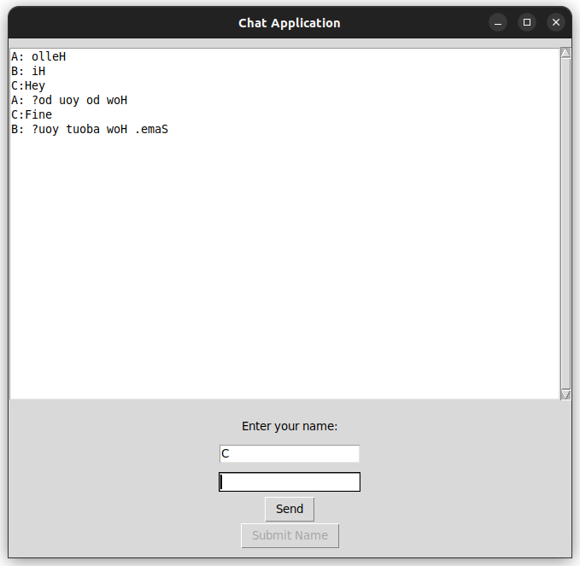

SERVER

oem@DALAB11:~/abhiram/EXP 3$ python3 server.py
Server is listening on localhost:56789...

